| **Narrogin SHS Year 11 ATAR CHEMISTRY Name:** | |
| --- | --- |
| Task No: | 7 |
| Task Type: | Test |
| Content: | Chemical reactions; Calculating chemical quantities |
| Task Description: | Complete the attached questions on the multiple choice answer sheet or in the spaces provided.  Marks will be awarded for presentation and working.  **Test conditions (50 minutes).**  *Formulae and data booklet provided.*  *Non-programmable calculator permitted.* |
| Total Marks: | 32 |
| Weighting: | 2.15% |
| Due Date: |  |

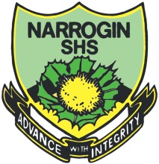

**IMPORTANT NOTE TO CANDIDATES**

No other items may be taken into the examination room. It is **your** responsibility to ensure that you do not have any unauthorised notes or other items of a non-personal nature in the examination room. If you have any unauthorised material with you, hand it to the supervisor **before** reading any further.

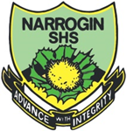

**Multiple Choice Answer Sheet**

**Task Number: __ Name: _______________ Year: __**

**Multiple Choice – 10 questions.**

Circle your choice. If you change your mind, scrub your choice out and circle the one you want. If it is messy, clearly write your choice next to question.

1. A B C D

2. A B C D

3. A B C D

4. A B C D

5. A B C D

6. A B C D

7. A B C D

8. A B C D

9. A B C D

10. A B C D

**Section 1: Multiple Choice**

*Indicate your answers on the multiple choice answer sheet*

1. Which of the following describes the mass of Avogadro’s number of particles  
    (6.02 x 1023)?
2. 10g of sodium hydroxide
3. 32g of oxygen gas
4. 9g of water
5. 55g of hydrochloric acid
6. The percentage composition of MgCl2 is
7. %Mg = 25% : %Cl = 75%
8. %Mg = 40% : %Cl = 60%
9. %Mg = 30% : %Cl = 70%
10. %Mg = 20% : %Cl = 80%
11. Which of the following equations is not balanced?
12. 2KClO3 🡪 2KCl + 2O2
13. Fe2O3 + 3CO 🡪 2Fe + 3CO2
14. Zn + 2HCl 🡪 ZnCl2 + H2
15. 2HgO 🡪 2Hg + O2
16. Which of the following equations is NOT balanced?
17. 2H2S(g) + 3O2(g) 🡪 2H2O(g) + 2SO2(g)
18. 2C2H6(g) + 7O2(g) 🡪 4CO2(g) + 6H2O(g)
19. HCl(aq) + NaOH(aq) 🡪 H2O(l) + NaCl(aq)
20. 3NO(g) + 2O2(g) 🡪 3NO2(g)
21. Which of the following equations shows only the reacting species (i.e. does not contain any spectator ions)?
22. 2NaI(aq) + Pb(NO3)2(aq) 🡪 PbI2(s) + 2NaNO3(aq)
23. Ag+(aq) + Cl-(aq) 🡪 AgCl(s)
24. Ba2+(aq) + 2NO3-(aq) + 2Na+(aq)+ SO42-(aq) 🡪 BaSO4(s) + 2Na+(aq) + 2NO3-(aq)
25. Ca2+(aq) + 2NO3-(aq) + 2K+(aq) + CO32-(aq) 🡪 2K+(aq) + 2NO3-(aq) + CaCO3(s)
26. Which of the following statements is INCORRECT?
27. An exothermic reaction releases heat and has a negative H.
28. In an exothermic reaction the temperature of the surroundings would decrease.
29. In an exothermic reaction the products have a lower enthalpy (heat content) than the reactants.
30. An example of an exothermic reaction is the combustion of methane.
31. Which of the following is endothermic?
32. Burning magnesium metal
33. Condensation of water
34. Melting candle wax
35. Adding concentrated acid to water
36. Which of the following graphs shows the enthalpy changes involved in an endothermic reaction?

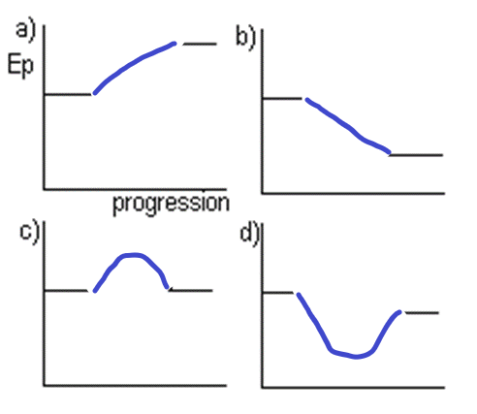

1. Consider the following equations

i) C4H10 + 6O2 🡪 4CO2 + 5H2O ΔH = -2727kJ

ii) 6CO2 + 6H2O 🡪 C6H12O6 + 6O2 ΔH = 2816kJ

iii) CO + O2 🡪 CO2 ΔH = -283kJ

iv) C3H8 🡪 3C + 4H2 ΔH = 104kJ

Which equations are exothermic?

1. i, iii and iv
2. i and iii
3. iii and iv
4. ii and iv
5. Study the following two equations:

I. H2(g) + ½O2(g) → H2O(g) ΔH = -242 kJ

II. H2(g) + ½O2(g) → H2O(l) ΔH = -285 kJ

The best explanation for the difference in the values of ΔH for these two reactions is

1. More heat is given off in equation I because the water is in gaseous form.
2. Water vapour has greater enthalpy than liquid water so reaction II releases more heat energy to its surroundings.
3. Water in the liquid phase has more stored energy then water vapour so reaction II releases less heat energy to its surroundings.
4. Water in the liquid phase stores less energy than water vapour and so releases less heat energy to its surroundings

**Section 2: Short Answer**

*Write your answer in the spaces provided*

1. Determine the molar mass of
2. ammonium oxalate (NH4)2C2O4
3. zinc iodide
4. sodium carbonate-2-water

(3 marks)

1. Calculate the number of moles of molecules in 210g of octane C8H18

(2 marks)

1. Nitrogen is the active element in many fertilisers. Determine the percentage of nitrogen by mass in the following common fertilisers
2. ammonium nitrate (NH4NO3)
3. urea (NH2CONH2)

(4 marks)

1. Determine the mass of carbon in 3.58g of urea (NH2CONH2)

(4 marks)

1. Write balanced ionic equations for the following
2. Liquid ethanol (C2H6O) is burned in oxygen gas to produce water vapour and carbon dioxide
3. Solid calcium carbonate is treated with diluted hydrochloric acid to produce carbon dioxide, water and calcium chloride solution

(4 marks)

1. Sketch an energy profile diagram for the reaction shown in 6a) if the Ʌ= - 176 kJ

(5 marks)

**END OF TEST**